**Advance Excel Assignment 1**

1. What do you mean by cells in an excel sheet?

Ans: In an excel, A cell is a rectangular box that occurs at the intersection of a vertical column and a horizontal row in a worksheet.

Vertical columns are named by alphabetic values such as A, B, C. Horizontal rows are named by numeric values such as 1, 2, 3.

1. How can you restrict someone from copying a cell from your worksheet?

Ans: By entering password, we can secure our worksheet from getting copied by others. We need to go into **Menu bar >Review > Protect sheet > Password**.

1. How to move or copy the worksheet into another workbook?

**Ans**: Open the workbook that you want to move the sheet to.

On the Window menu, click the workbook that contains the sheet that you want to move.

On the Edit menu, click Sheet > Move or Copy Sheet.

On the To book menu, click the workbook that you want to move the sheet to.

4. Which key is used as a shortcut for opening a new window document?

Ans: CTRL+N is used to opening a new window document.

5. What are the things that we can notice after opening the Excel interface?

Ans: We notice after opening the excel interface mentioned in below picture:

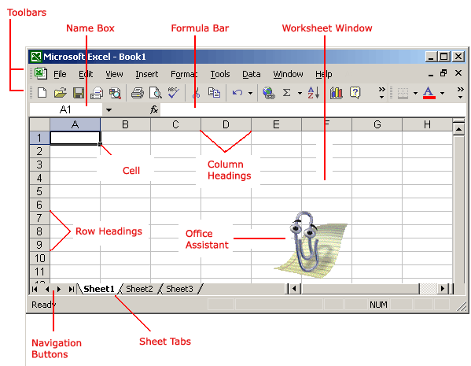

1. Cells: A rectangle place where we perform crud operations.
2. Column Headings: 256 columns are in excel and named by alphabet.
3. Workbook: Also called a spreadsheet, the workbook is a unique file created by Excel XP.
4. Title bar: It shows file name of excel.
5. Menu bar: It shows all available menus.
6. Row Headings: Each spreadsheet contains 65536 rows and named by a number.
7. Name Box: It shows the address of current selection or active cell.
8. Cell: A cell is an intersection of a column and row. Each cell has a unique cell address.

6. When to use a relative cell reference in excel?

Ans: Whenever you need to repeat the same calculation across multiple rows or columns then

We use relative cell reference in excel.